**Data:**

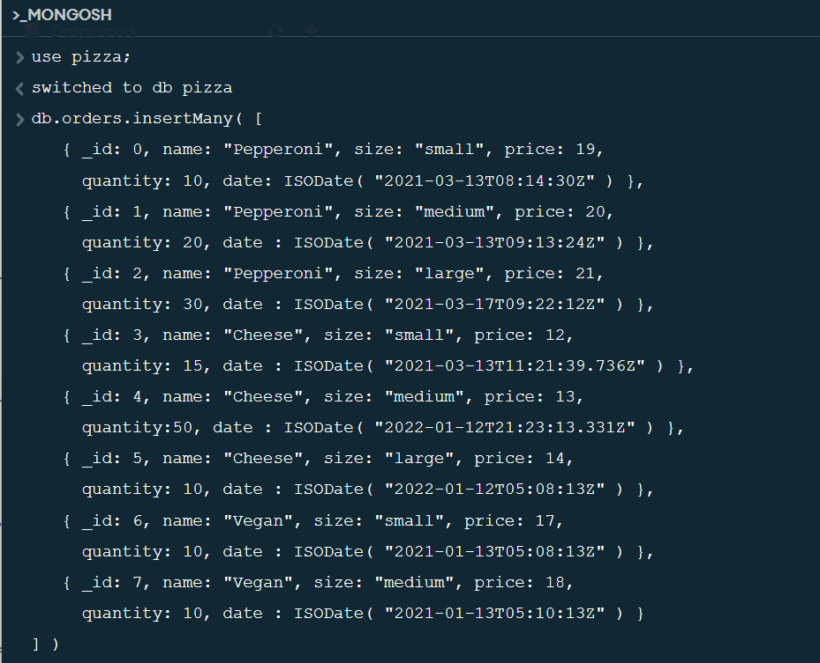

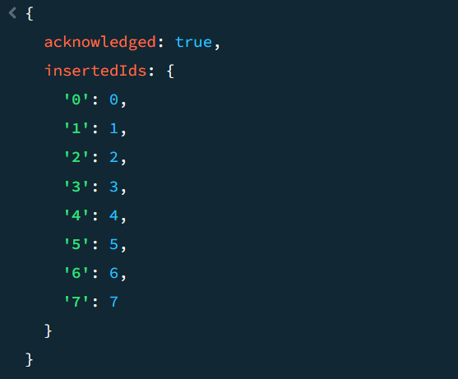

**Example 1:** (on MONGOSH)

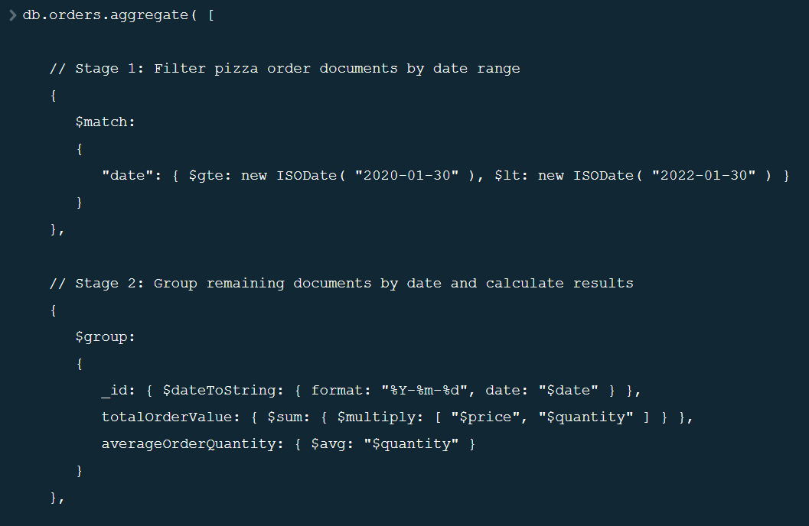

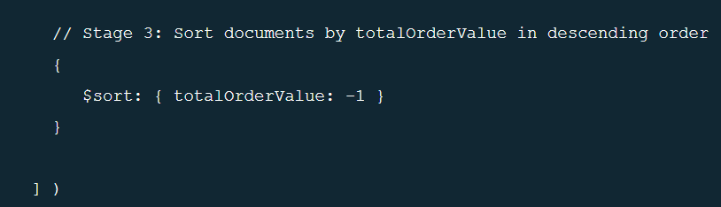

**OUTPUT:**

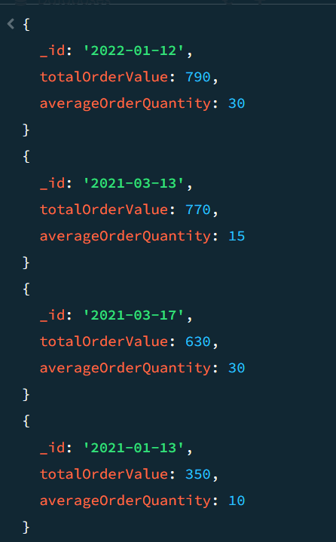

**Example 2:** (with GUI)

Aggregation Pipeline with 8 stages:

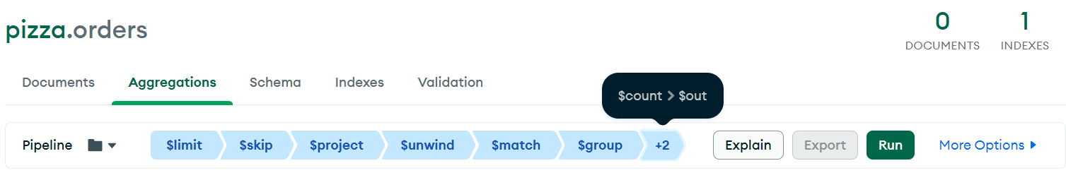

[

{

$limit:

/**

* Provide the number of documents to limit.

*/

5,

},

{

$skip:

/**

* Provide the number of documents to skip.

*/

1,

},

{

$project:

/**

* specifications: The fields to

* include or exclude.

*/

{

_id: 1,

name: 1,

price: 1,

quantity: 1,

size: 1,

newfield: [1, 2, 3],

},

},

{

$unwind:

/**

* path: Path to the array field.

* includeArrayIndex: Optional name for index.

* preserveNullAndEmptyArrays: Optional

* toggle to unwind null and empty values.

*/

{

path: "$newfield",

},

},

{

$match:

/**

* query: The query in MQL.

*/

{

size: "medium",

},

},

{

$group:

/**

* _id: The id of the group.

* fieldN: The first field name.

*/

{

_id: "$name",

totalQuantity: {

$sum: "$quantity",

},

},

},

{

$count:

/**

* Provide the field name for the count.

*/

"totalQuantity",

},

{

$out:

/**

* Provide the name of the output collection.

*/

"merged_orders_collection",

},

]

